Introduction to visits to Social Entrepreneurs
and Social Economic Enterprises
in Copenhagen, Denmark,
June 2018.

The following is a brief introduction to visits, we will make in Copenhagen.
You will read a bit about each of the places, and hear a little about the persons and the history behind the activities.

In Copenhagen there are very, very many activities taking place; some of which were founded a long, long time ago, while others have been established within the last 5 or 10 years.

All in all, we hope these visits will give you an idea about the variety of social entrepreneurship and social economic businesses in Copenhagen.

Programe

Tuesday 19 June
11.30-12.00
Adress: Slagterhusgade 10, 1. Sal, 1715 København V
Tiny Garden
Presentation by Helle Haugaard, founder of Tiny Gardens

12.00-13.00
Adress: Slagterhusgade 10, 1. Sal, 1715 København V
Lunch at Foodspace

14-15.30
Adress: Tomsgårdsvej 19, 3.sal, 2400 København NV
Blindes Arbejde
Presentation by Kristin Espedal

16.30
Adress: Slagterhusgade 10, 1. Sal, 1715 København V
Association for Social Innovation and Foodspace
Presentation Thorleif Jeppesen

17.00-19.00
Cooking and having dinner together
Wednesday 20 June
10.00-11.00
Adress: Gladfonden, Rentemestervej 45-47, DK-2400 NV
International master Social Entrepreneurship and Management at Roskilde University
Presentation by Louise Li Langergaard
11.00-12.00
Adress: Gladfonden, Rentemestervej 45-47, DK-2400 NV
Introduktion to Gladfonden
Presentation by CEO Mikkel Holmbäck

12.00-13.00
Adress: Gladfonden, Rentemestervej 45-47, DK-2400 NV
Lunch – Gladfonden

14.00-17.00
Free afternoon

17.00-18.00
Adress: Folkehuset Absalon, Sønder Blvd. 73, 1720 København
Introduktion to Community House Absalon

18.00-19.00
Adress: Folkehuset Absalon, Sønder Blvd. 73, 1720 København
Dinner

Thursday 21 June
Adress: Settlementet, Dybbølsgade 41, 1721 København
Introduktion to Settlementets Social economy street
Presentation Margrethe Wivel, CEO of Settlementet
12.00-13.00
Adress: Saxogade 86, 1662 København V
Lunch
”Café Sonja”,

13.30-14.00
Adress: Social Foodies shop, Gammel Kongevej 115, 1850 Frederiksberg
Introduktion to Social Foodies
Per Bach, Social Entrepreneurs in Danmark

18.00-19.00
Dinner
Depending on when flights are leaving

The Settlement - Settlementet
http://settlementet.dk/
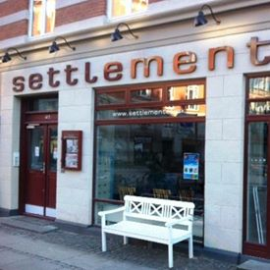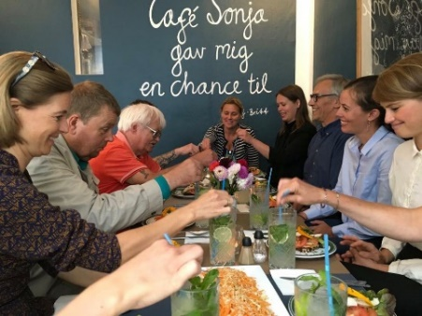
In the western part of Copenhagen, The Settlement is a social street of commence, based on a vision for social economic sustainability and solidarity. It was established in 1911, and has developed over decades, and is very experienced in tackling the urban, social and economic challenges of the community. It was one of the poorest areas of the city by then. They know how to interact with the local social authorities, and initiate activities, that include and empower people. Volunteers and academics moved in and educated the locals.
The Settlement offers help for adult citizens, who do not receive enough help or the right help, as part of the welfare society, nor the municipality of Copenhagen. They involve the citizens of the city into a diverse local community, where everyone is welcome. They aim to work for social and cultural equality in society and bridge between different communities and individuals, across generations and across social and cultural boundaries.
They believe everyone has value and something to contribute. Therefore, they work to create hope, development and meaningful (working) communities, by ensuring that each individual can unfold his or her potential in the community. By participating in the working community of The Settlement, people experience a new and common room for inclusion and equality of differences.
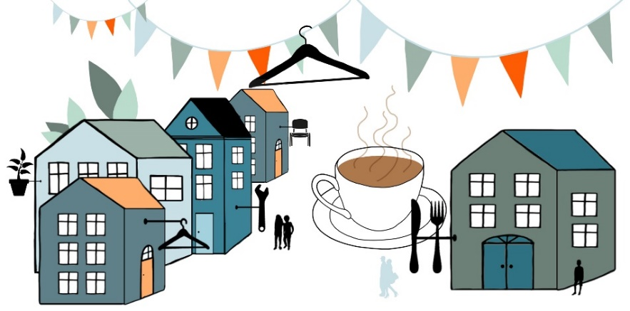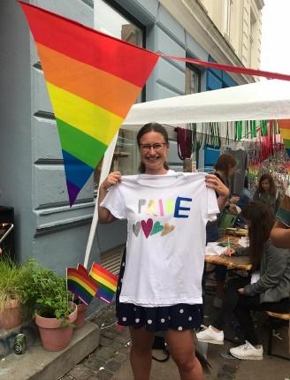
Settlementet runs several activities in two streets: Saxogade and Lyrskovsgade - cafes, shops, recycleling activities, festival and street events, counselling and many other things, all as part of a social economic approach to the problems and challenges of the community. Settlementet has around 100 volunteers and 50 employees. More than 1.000 citizens per year are involved and receive help.
Gladfonden – The Happy Fondation
Mikkel Holmbäck, CEO, 26 22 09 47, mikkel@gladfonden.dk
http://www.gladfonden.dk/
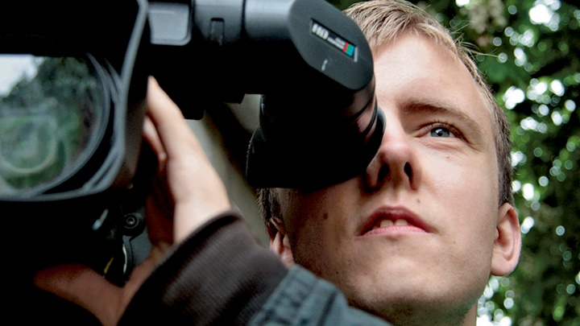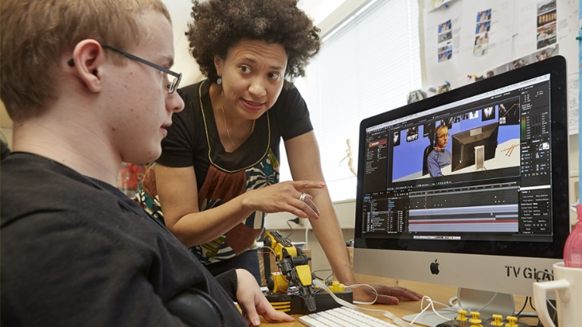
Glad Fonden, The Happy Foundation, started off in 1999 as the first TV-station in the world, that works for and with people with a physical or mental handicap. Including disable people will make our society richer, happier and more inspiring. Glad Fonden works as a social economic enterprise, and cover various kinds of activities; within media, kitchen, catering, café, theater, education and work, as well as culture and design work.
“We educate and hire people with and without a handicap to produce services, products, cultural experiences, and content to various media, in a quality that can compete on general market terms. We aim to change years of misunderstood care culture, and provide disabled people with freedom of expression, and opportunities to contribute to society by means of both the companies of the foundation, as those of the society in general.”
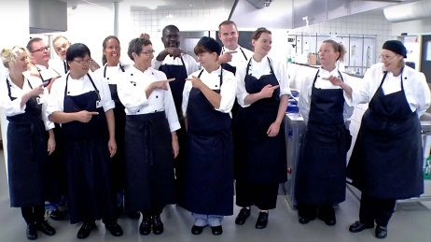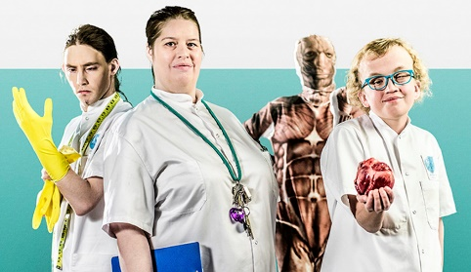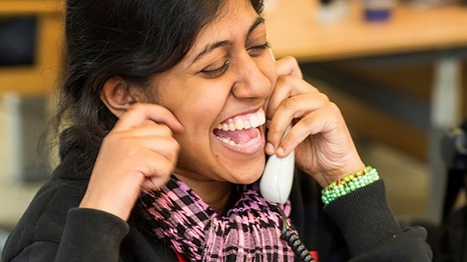
Around 250 persons are employed and 65 persons studies at the school. There are local divisions in several cities throughout the country; the capital, Copenhagen as well as Ringsted, Kolding, Vejen, Esbjerg og Aabenraa.

Blindes Arbejde – The Work of Blinds
http://blindesarbejde.dk/ - Kristin Espedal, CEO, 38 3334 88
https://www.facebook.com/blindes.arbejde/

The Work of Blinds is a business fund and a social economy company that works to get blind and ill-considered in work, primarily in the manufacture of brushstuff, weaving, costing, braiding and retail work. The foundation was established in 1929. Around 60-70 employees work in The Work of Blinds. The first store opened in 1993 in Copenhagen. Since several stores have opened in Århus (1999) and Horsens (2006) and Odense.
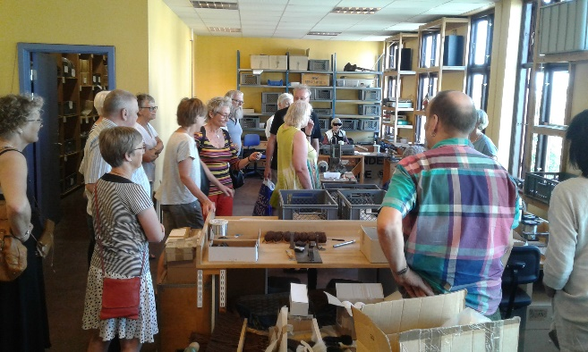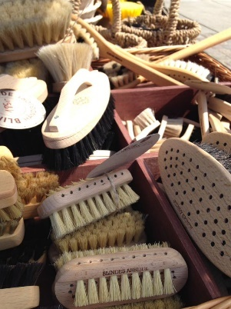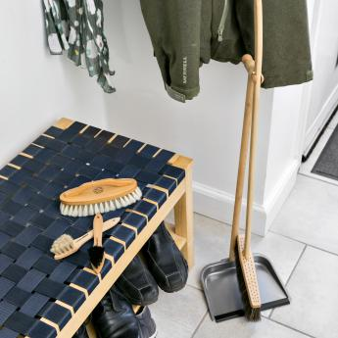

Our good story is balancing between good workmanship and sustainable social economy. The Work of Blinds was founded in 1929 as a company. Since 1984 the company was a self-employed rehabilitation institution with an operating agreement in the municipality of Copenhagen. In 2005, the company was established as a self-employed fund. Since the foundation in 1929, the work of Blind has been nationwide.
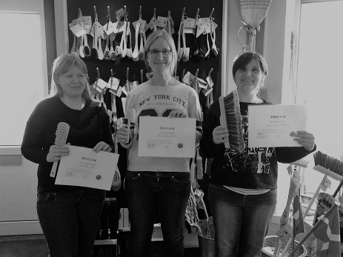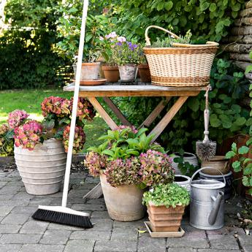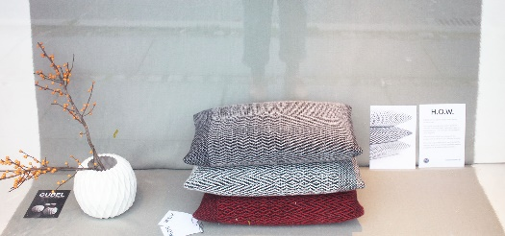

We are a craft company that manufactures products for private households, businesses and municipal workplaces who need cost, brushes, textiles and baskets of good raw materials and with long durability.
We educate to produce and work; people graduate and receive a diploma for their competences.

Co-designed pillows received a price and a lot of attention
It was with great pleasure and enthusiasm that the staff in the weaving department experienced, that their co-designed textiles and new branded H.O.W. pillows could be sold in our own stores. The co-design project was started in 2014. The work has been done on different designs and made new employees come into co-operation. It all received a lot of attention, especially with a design price in 2017.

The Work of Blinds - Point of mission, vision and values
- Our mission is to create more job and employment opportunities for the blind and weak-minded, and we do so by raising awareness of the "smart hands" and "present customer service" as strong competencies and resources.
- Our vision is to be nationally and internationally recognized for our design and craft products, as well as current customer service in all our sales channels. This with a clear balance between our social and economic sustainability.
- Our values ​​are Responsible Spatiality, Quality and Service, Flexibility and Development.

Amager Æblemosteri - Cider Work in the area of Amager
Lya Moestrup, CEO, founder http://amageraeblemosteri.dk/ https://www.facebook.com/search/top/?q=frugtplukkerne

Amager Cider Work is a partnership between two partners: Kofoed School, and the association, The Fruit Pickers. The cooperation aims to establish a local and social Cider Work in Amager, involving vulnerable citizens in both production and sales, and thus strengthen them socially and professionally. On a volunteer basis, they try to develop a sub-culture about using the unused fruit resources in private gardens, and thus create new local communities across the area.

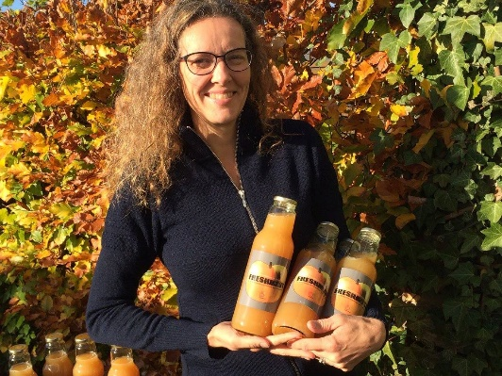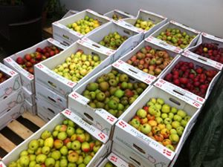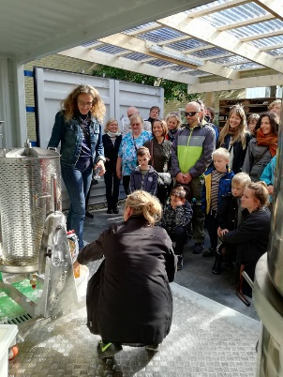

Amager Cider Work is a partnership between two partners: Kofoed School, and the association, The Fruit Pickers. The cooperation aims to establish a local and social Cider Work in Amager, involving vulnerable citizens in both production and sales, and thus strengthen them socially and professionally. On a volunteer basis, they try to develop a sub-culture about using the unused fruit resources in private gardens, and thus create a new local communities across the area.
The Kofoed School provides help to self-help for people with social difficulties, by means of education, training, treatment, rehabilitation, emergency assistance and support for personal development. Through its efforts, the school wishes to help the individual student to develop increased resources Denmark's first social metropolitan area has now been opened at Amager. Mosteriet is located at Kofood School in Nyrnberggade, and the gathering and mashing of all the apples that more than 80 gardeners at Amager have already been allowed to pick up are already full. Kofoeds School works to emphasize and organize the inclusion of it’s pupils and course participants.

The Fruit Pickers works to include the commons; the local people and citizents of Amager - and not least their apples - into the work about creating opportunities for vulnerable young people throughout Amager. The Fruit Pickers also do social entrepreneurship courses for pupils in primary school. The Fruit Pickers wish to open up for an interest in exploiting garden fruit, and include vulnerable citizens, and combine social entrepreneurship with the production of local food. It is a goal to reach out across the region of Amager and thus make more people aware of the possibilities in local and socially including food production.
Tiny Gardens
Helle Haugaard, CEO, founder https://tinygardens.dk/

Tiny Gardens aims to spread the opportunity and joy of cultivating and eating sprouts, and thus inspire to a healthy and green lifestyle. We will help to create a more inclusive labor market by being a workplace for diversity.

Tiny Gardens works to get plants, people and ideas to grow. This with green concern in all our processes. We provide easy and healthy green solutions for both private and business. We create added value for individuals and businesses - A spire at a time!
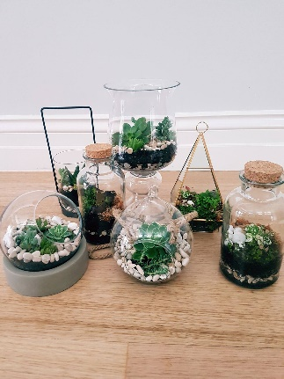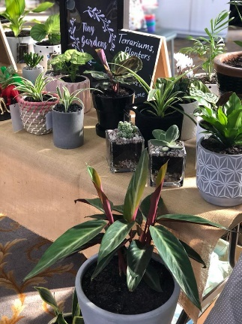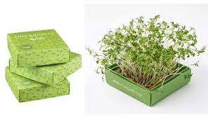

Tiny Gardens works as a social economic business; that is a private enterprise, earning money under normal market conditions, but for promoting its social purpose through its work and earnings. Tiny Gardens contribute with a socially including workplace and products, that inspires to live healthy and green.
Tiny Gardens works to inspire children to grow plants and vegetables, and uses toys as a method to attract attention and involvement.

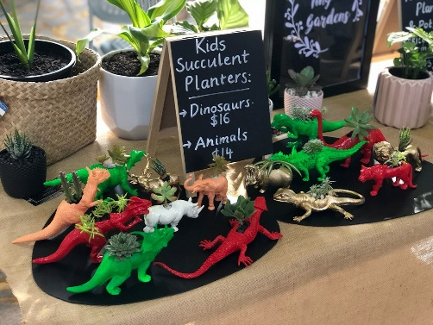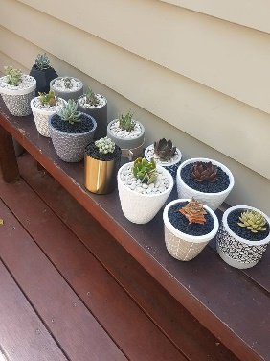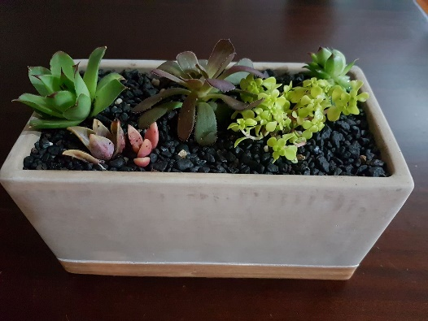

Sustainability is to choose materials with a good environmental profile for the products and to think and act as local as possible. When you grow a little of your own food, you contribute positively to reducing the transport of, for example, herbs from Holland.

Tiny Gardens is ecologically authorized by the Danish authorities with authorization number 1105851. We only use organic seeds, which we maintain strict status and are subject to control by the Ministry of the Environment and Food.

Social Foodies
www.socialfoodies.dk https://www.facebook.com/Socialfoodies.dk/?ref=br_rs

Social Foodies produces daily different ice and chocolate variants, based on ecologically produced products, made in Africa by well educated, and supported farmers. Social Foodies is a sustainable quality concept that helps socially vulnerable through projects in both Africa and Denmark. They work to create profits for investment in projects that ensure education and jobs.

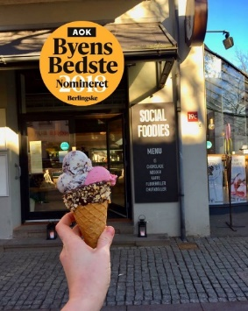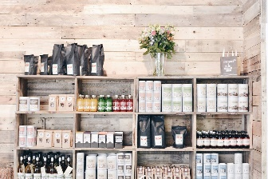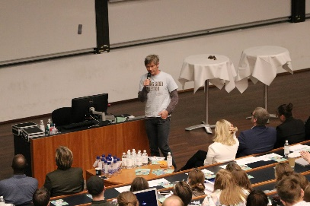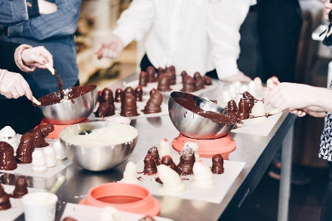

Social Foodies do not wish to compromise on the quality, so all new products are tested before they go into sale in the stores. Social Foodies experiment with new flavor combinations in the various products, which makes the products unique and personal.

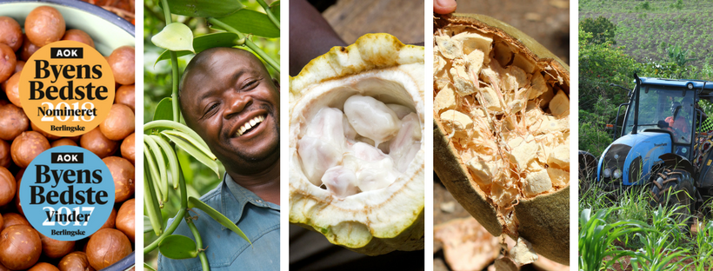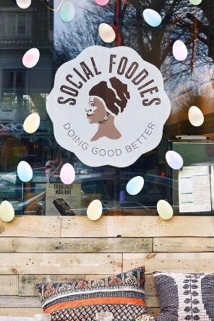

The goal of Social Foodies is to be involved in the entire value chain: From the work of the peasants to the finished product. They work to create value in various ways; also by providing local support to each individual in the South to develop and support his family. They do that by training in ecological agriculture and sustainable environment. The goal is to ensure growth and improved finances for all parties. Through this model they can create unique quality at good prices - and benefit people in Denmark and Africa.

For the social entrepreneur Thor Thorøe, business is both about earning money and taking a social responsibility. The combination is crucial! He has been working hard, and has made a great work: Today 7 Social Foodies shops have opened up in Denmark: In the region of Copenhagen, Social Foodies has 6 shops, and the one more has opened in Århus, the other end of Denmark, and the 2.largest city in Denmark.

Absalon – From church to House of the People
https://absaloncph.dk/ Adr: Sønder Boulevard 73, Kbh V
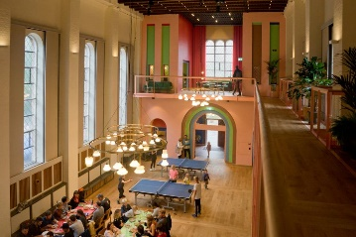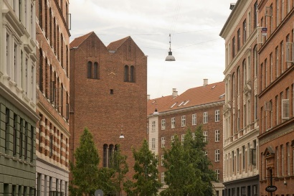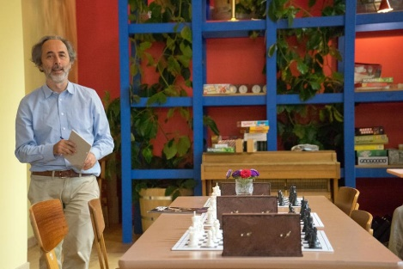
The former Absalon church is now Vesterbro Folk House. Here, local residents and other people in Copenhagen can meet and be together in new ways. One can meet a neighbor, hang out with friends or bring the family. From kl. 7pm until midnight Absalon is open, and every evening there is a community dinner at 18.00. It costs 50 kr. Person, but Friday 100 kr. Two vegetarian meals a week. One sits together at long tables - and eat, and meeting and talk together.
During the week there are a variety of activities: Table tennis, concerts, movies, yoga, treaties, etc. But the place is just as much a place you can come to be together. Children and adults play games and enjoy themselves. The place can be seen as an extension of your own living room - filled with friends, family, table tennis, music, backgammon, movies, bingo, food, coffee, chess, yoga, flea markets, sheet music, lectures.

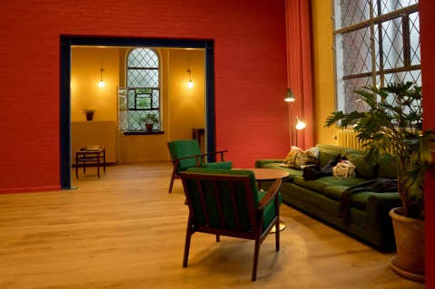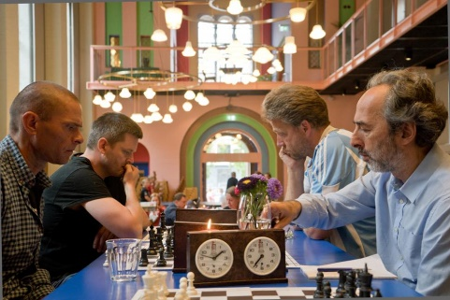

The story of Absalon - and the man behind Absalon as Folkehus
In August 2015, Absalon opened as a People's House. It is a privately run cultural and assembly center with activities and community dining. Absalon is a self-appointed public house. Originally, Absalon was a church, built in 1934. But as 7 other public churches, it was taken out of use in 2014. They were not used enough, so their use was reconsidered and it opened up the sale. Absalon was then bought for 10 million. DKK., and then renovated for an unknown amount of Danish businessman, Lennart Lajboschitz. He and a number of volunteers, associations and employees now stand behind the Absalon People’s House. Lennart Lajboschitz is a 56-year-old enthusiast and entrepreneur; he became billionaire with his international store chain, The Tiger: In 2012, he sold 70% of the chain. Among other things, he used the surplus create Absalon. It has been a major change: Now people like the place; they wish to participate and contribute. The idea was to create a space of social value and relations: "We believe, that what makes life worth living, is the social ties we associate with each other - and with Absalon we want to create a framework for exactly that kind of activity."
Master Programme Social Entrepreneurship and Management
At Roskilde University
https://ruc.dk/social-entrepreneurship-and-management-etfagskandidat
The Master Programme Social Entrepreneurship and Management (SEM) is inter-disciplinary and draws upon areas such as sociology, organization leadership and governance as well as research in social innovation, social enterprise, CSR and social accounting. You learn a wide-range of theories, concepts and practices within the following fields:
- Social entrepreneurship, social enterprise and social responsibility
- Innovation, capabilities and resource development
- Managing and organizing social enterprises
Students gain skills for initiating, analyzing and managing social innovation processes. By exploring leadership and management processes in complex, multi-dimensional organisations, the programme aims to prepare academically-oriented practitioners for the reality of running, shaping and transforming the next generation of social enterprises and innovation-led organisations.

